Heating Curve WebQuest Name __________________________ Per __

Part 1 Directions - Graph a Heating Curve  - Title your graph “Heating Curve of Water.” Plot the data provided in the table, with time on the x-axis and temperature on the y-axis. Make it a line graph by connecting the points you graphed.  - Circle the temperature on the y-axis that is the boiling point of water. Draw a green dashed line horizontally at this temperature.  - Circle the temperature on the y-axis that is the melting/freezing point of water. Draw a green dashed line horizontally at this temperature.  - Label the sections on your line that are: solid, liquid, gas.  - In red: Write the word melting and an arrow to the right on the line between solid and liquid.  - In red: Write the word boiling and an arrow to the right on the line between liquid and gas.  - In blue: Write the word freezing and an arrow to the left on the line between liquid and solid.  - In blue: Write the word condensing and an arrow to the left on the line between gas and liquid. | Time (min) | Temp (°C)
 | 0 | -9
 | 1 | -6
 | 2 | -3
 | 3 | 0
 | 4 | 0
 | 5 | 2
 | 6 | 10
 | 7 | 20
 | 8 | 30
 | 9 | 40
 | 10 | 50
 | 11 | 60
 | 12 | 70
 | 13 | 80
 | 14 | 90
 | 15 | 100
 | 16 | 100
 | 17 | 100
 | 18 | 100
 | 19 | 100
 | 20 | 120
 | 21 | 142
 | 22 | 165
 | 23 | 190
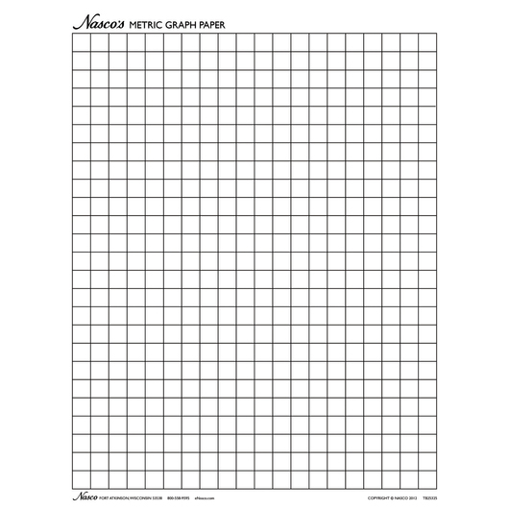

Part 2 Directions - Learn about Heating Curves
- Go to the website: https://tinyurl.com/thsphase2
- Scroll down the page until you see the phase change diagram under the section HEATING CURVE
- Read the website and answer the following questions

Questions:
- Look at the 3 sloped lines on the heating curve you drew in Part 1. Are the 3 slopes the same? Using the website: the slope of these lines depends on __________ and ___________________.
- When water reaches 100°C it begins to boil. What happens to the temperature until ALL of the water has been boiled and converted into steam?

- Once all of the water has been converted to steam, what happens to the temperature?

- What happens to temperature during a phase change?
- During a phase change, what is the added heat being used for?

- Why is the horizontal line at 100°C (between liquid and gas) longer than the horizontal line at 0°C (between solid and liquid)?

Part 3 Directions - Thermal Energy
Matter consists of atoms and molecules. Changing the state of a substance requires energy. Adding or removing thermal energy from a substance often causes a change of state. Energy affects the attraction between the atoms and their rate of movement. A substance’s temperature determines whether it occurs in a solid, liquid, or gas state.
A different amount of energy is needed to change the state of different substances. For example, it takes more energy to melt a solid metal into a liquid than to melt an ice cube into water. In this virtual lab you will examine how energy affects the state, the molecular activity, and the temperature of a substance.

- Go to the website: encoe.mcgraw-hill.com/sites/007877846x/sitemap.html
- Scroll down to Chapter 4: States of Matter and click on the Virtual Lab link
- Click on the virtual lab ‘How does thermal energy affect the state of a substance?’
- Click the Video button and Play the video.

Video Question:
What are 3 pieces of data you can measure to identify an unknown substance?

- Click on one of the substances: Water, Mercury, or Iron. The selected substance appears in its solid form inside the Energy box. This box is able to add thermal energy to the substance or remove energy from the substance at a constant rate. Inside the box, a sensor records the temperature of the substance.
- Predict what will happen to the state of the substance, the molecule activity, and the shape of the heating curve when thermal energy is ADDED to the solid.

- Click the Heat button. Observe what happens. Draw what the atoms look like in the circle below.
- Click the graph button to see a printout of a temperature vs. time graph that shows what happened when heat was added to the solid substance. Draw the line below.

- Click the Heat button. Observe what happens when MORE heat is added. Draw what the atoms look like in the circle below. Draw the updated graph below.

Determine the approximate melting, boiling and freezing points of the 3 substances by reading the graphs. Record this data in the table.
Substance | Melting Point (°C) | Boiling Point (°C) | Freezing Point (°C)
Water
Iron
Mercury

