1. Draw a wave and label the: wavelength, and amplitude.
2. What is the relationship between wavelength, frequency & energy?
3. Explain why an element gives off light when it is heated or electricity passes through it. (think electrons- read packet p. 8)
4. Define electromagnetic spectrum.
5. List all of the types of radiation in the electromagnetic spectrum in order of decreasing energy

**You will be given the formulas and the constants: *Speed of Light, C=3.00 x 108 m/s, Planck’s constant,* h=6.63 x 10-34 J x s**

6 a) Define each variable in the formula: **c= λv : _______________________________________________________________**

b) A laser emits light at the wavelength of of 4.74 x 10-12 m. What is the frequency of the light?

c) The blue color of the sky results from the scattering of sunlight by air molecules. The blue light has a frequency of about 7.5 x 1014Hz. What is the wavelength?

7. a) Define each variable in the formula: **E=hv** :__________________________________________________________________

b) What is the energy of a photon of ultraviolet radiation with a frequency of 14.20 x 1011 sec-1?

8. The electron behaves both like a wave and a particle (use your notes and re-watch this video for extra help: [**https://www.youtube.com/watch?v=MFPKwu5vugg**](https://www.youtube.com/watch?v=MFPKwu5vugg)). Explain this idea

**9. Know the difference between fission, fusion, and radiation.**

1. What happens during fission?
2. What happens during fusion?
3. Give an example where fusion is happening___________ Where is fission happening? _________________
4. What is the difference between **Capture** and **Decay (emission)** reactions (explain or draw)?
5. Complete the following reactions AND indicate the type of radiation & if it is capture of decay (emission)

a. 21083Bi + 0-1e → _______ _______________________________

b. 16062Sm → 15660Nd + ______ _______________________________

c. 23090Th → ______ + 42He + γ _______________________________

1. Many radioisotopes undergo alpha decay. They emit an alpha particle (helium nucleus). For example,   
   Write similar balanced nuclear equations for the alpha decay of each of the following:   
    a. Pa-231 b. Am-241
2. Other radioisotopes undergo beta decay, emitting a beta particle (electron). For example, 

Write similar balanced nuclear equations for the beta capture of each of the

following: a. H-3 b. Mg-28

1. Write the equation for positron capture by silicon-26.
2. Sodium-22 undergoes neutron capture, then Hydrogen decay. Write the reactions & what is the final product?
3. Explain how radiation is used to diagnose and treat cancer. (you will need to look this up!)
4. The type of nuclear decay depends on the ratio of _______________ to ______________. (Make sure to review questions 7-12 on page 18)

18. Use the isotope Barium-138 the following questions:

* 1. How many protons does Barium-138 have? _______________
  2. Have many neutrons does Barium-138 have? _______________
  3. What is the mass of Barium-138? _______________
  4. What is the neutron to proton ratio for Barium-138? _______________
  5. 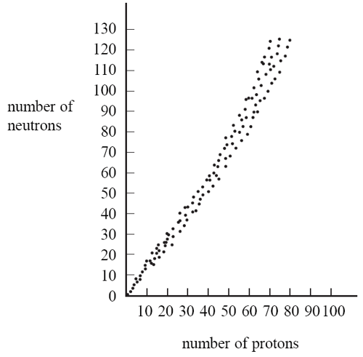Would this isotope be classified as radioactive or stable? _______________ (**use the band of stability diagram in question 19 )**

19. Use the band of stability graph to the right to Plot and identify which of the following isotopes are stable.

**Circle the stable isotopes**

a. ${}_{5}^{11}B$

b. ${}_{90}^{228}{Th}$

c. ${}_{47}^{115}{Ag}$

d. ${}_{75}^{190}{Re}$